Basic Difference
VLSI Enginners
-building the GPUs and the CPUs , bringing all the transistors togheter on a single chip
-In VLSI we have
- RTL Design
- Verification
- DFT
- Physical Design
Embedded System
-Building a system around the microproccesor made by the VLSI Enginners , any system you see which has a microcontroller is made by embedded system enginners
-Eg.Phones,Defence eqipments
- Software Embedded Enginner and Hardware Embedded Enginner
-Hardware Embedded Enginners develop the whole motherboard with the microprocessor embedded on it and complete all the connections to peripherals

Skills Required
For VLSI
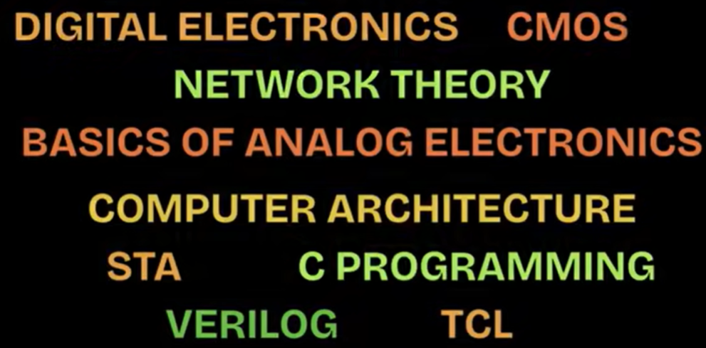

For Embedded
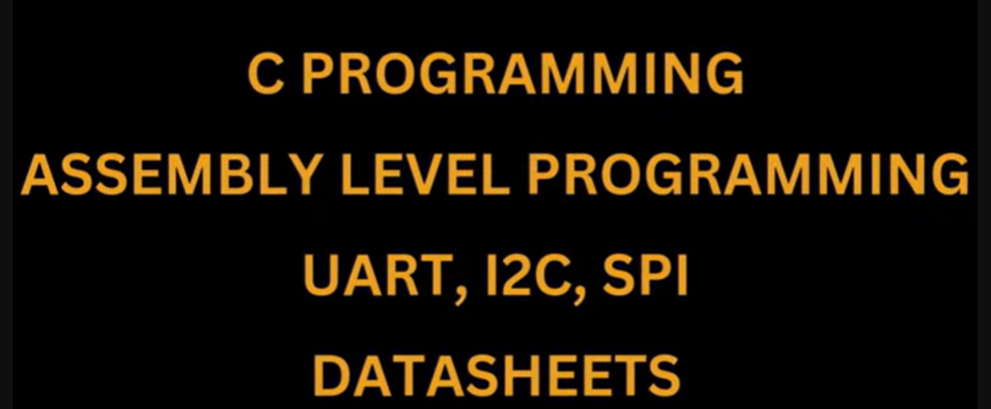
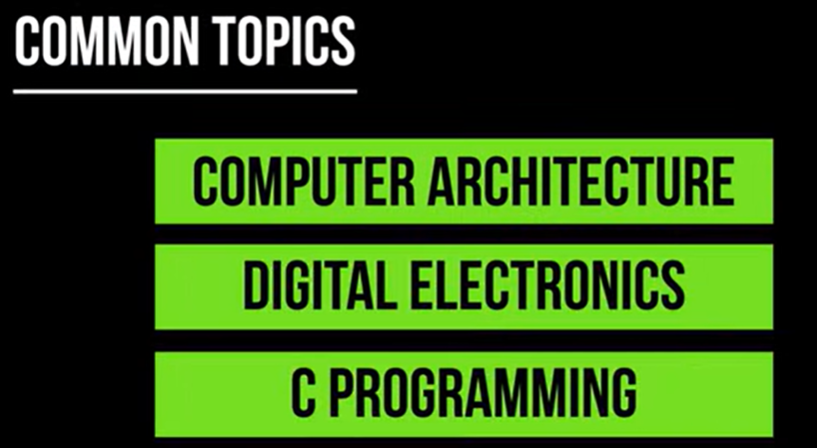
Mindset for VLSI
-For optimising the area,power and performance
Mindset for Embedded
-writing efficient C codes as you have memory constraints
-Barrier degree
IT<Embedded<VLSI
Job openings
IT>Embedded>VLSI

